**Survey guidelines in software engineering an annotated review.**

*Alisha Taj, Phani Kumar Pullela*

*School of Computer Science Engineering (SOCSE), RV University, RV Vidyanikethan Post, 8th Mile, Mysuru Road, Bengaluru – 560059*

**Abstract**

Software Engineering Surveys are Frequently research methods in an imperial way. Survey-based research has been used to capture the description of research. Research disciplines of Software Engineering regarding objectives and subjects. A literature review is a semi-structured Interview. and it must be fully focused on Software Engineering. The main objective of this study is to summarise and detail references based on the survey research in Software Engineering. there will research manuals and descriptions of valuable research are in Software Engineering.

**Keywords:** Computer Applications, Software engineering, Annotated pipe line, Survey Guidelines, Annotated review.

**Background**

The Survey Generalizes the findings, and the Aims are to identify problems in ‘different researches of Software Engineering facing subway designs and the mitigation strategies. The relevant citations were Collected in the paper articles A literature review is a semi-structured Interview. and it must be fully focused on Software Engineering. The main objective of this study is to summarise and detail references based on the survey research in Software Engineering. there will research manuals and descriptions of valuable research are in Software Engineering. The investigation will be conducted in empirical studies. Survey-based research capture research disciples. [1]

The Basic idea of a survey is to collect more sources and information to gather data from a huge economy of interest and is also used in Software Engineering Facing many challenges also the noted review faces immeasurable challenges in the review. The main aim of a survey is to gather more population by designing the data collection instruments. Software Engineering Surveys are Frequently research methods in an imperial way. Survey-based research has been used to capture the description of research. Research disciples of Software Engineering regarding objectives and subjects. Methodological ways of Survey provide valuable support to empirical Research. The subjects in them usually study well-qualified professional in different opinion areas. [2]

**Fig 1**

Survey guidelines search and select the process. which extract data extraction and Analysis have the following ways, Research method, Activities Impact, Reference, Instrument, Description. Survey guidelines steps are the method followed with the case study, experiment, and Action Research. Survey guidelines should Identify the research objects and characterize the Design sampling Plan, Picking and analysing results an Distribute it to more people.

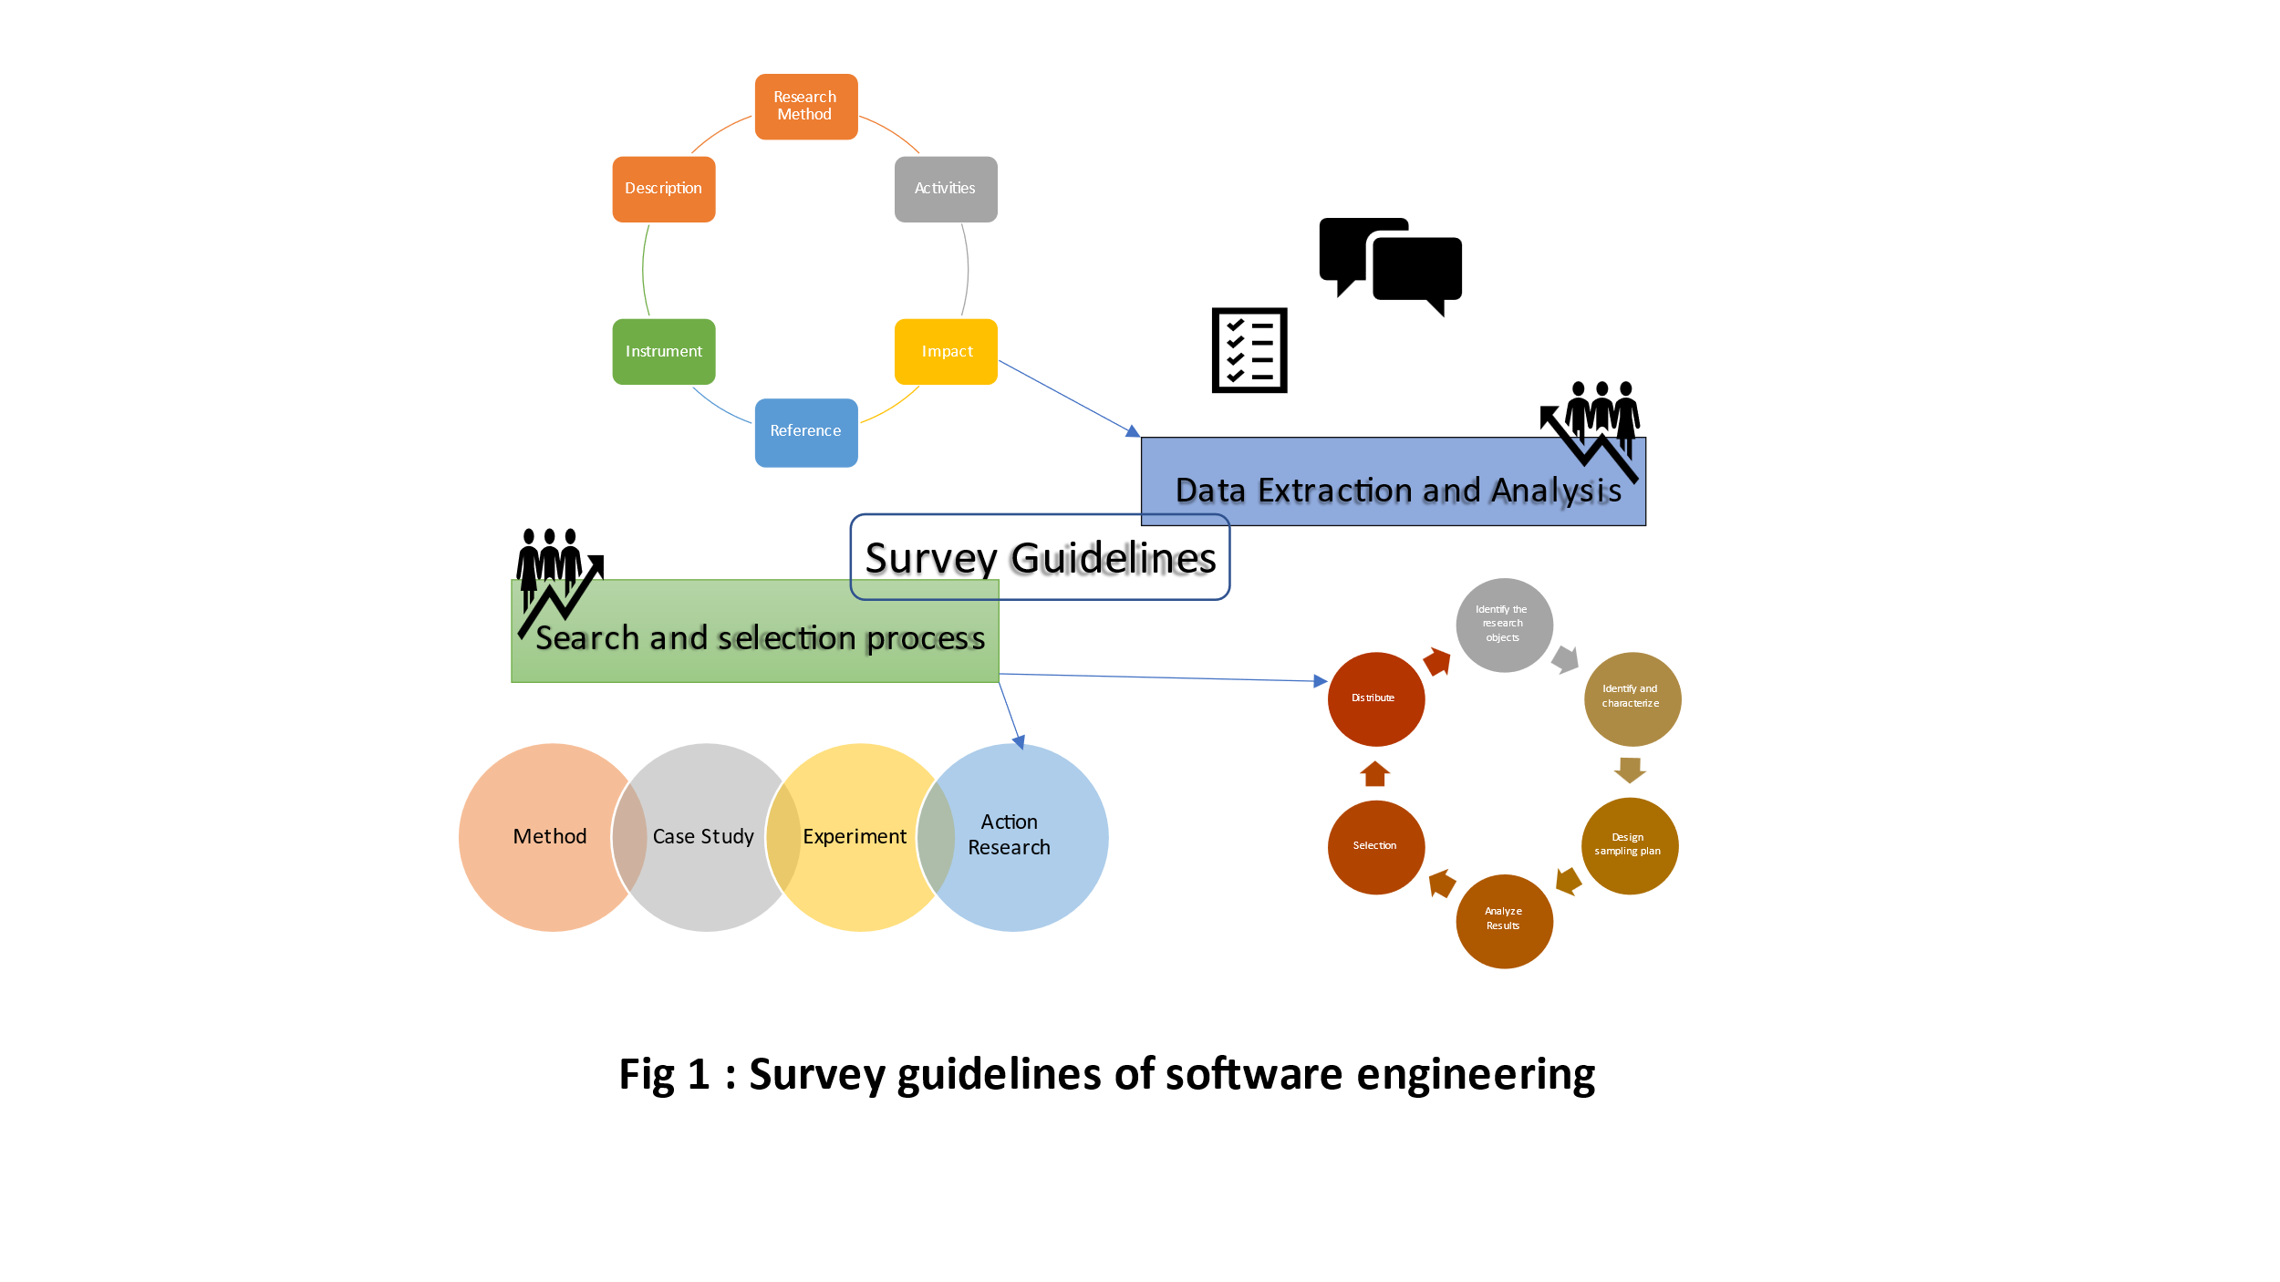

**Introduction**

Guidelines for conducting systematic mapping studies in software engineering are done in the use to structure a research area. The services are focused on gathering and synthesizing evidence. The most recent guidelines are from the Year 2008. It should evaluate the Research Conduct the systematic mapping and identify the guidelines updated based on the lessons from the existing systematic Maps and SLR guidelines. [3] Of artificial review of the state of sampling with high-quality software engineering research. The key findings are mere the samplings are where the sampling is rare also Sophisticated sampling strategies are very rare Mostly the sampling, representatives, and randomness are misunderstood, Software engineering has a general crisis. To clarify and clear all these problems. This topic synthesizes existing knowledge and proposes more guidelines for improving representation, conduction, and evaluation of Samples into Decent primer and proposes in conducting research in Software Engineering further recommended are researchers striving more representative samples disinteresting generally from qualitative research. [4] The Systematic review in software engineering researches of adopting reviews has published a paper discussing many problems with Methodology and improving it Textual analysis tools are likely to be useful for decisions and require more stringent evaluation the guidelines were updated 2007 Software Engineering researchers would benefit from tools to manage the process... The existing tools need independent validation. The empirical method major problem in quality. [5]Lessons from applying the systematic literature review process within the Software Engineering domain are consequences of the growing number of empirical studies which is needed to adopt a systematic approach to access and aggregate research outcomes that provides a balance objective summary of research evidence for a topic. The basic systematic literature review process seems appropriate for Software Engineering and preparing, and validate of a review protocol. which is mainly valuable. The paper reports experience by applying the approach and literature. The Standard electronic data recording form is conducted in the Data extraction process. [6] Systematic literature reviews in software engineering literature review (Evidence-based software engineering aims to apply and approach research and Practice. Evidence-Based research and practice were developed initially in medicine because research indicated that expert opinion-based medical advice was not as reliable as advice. The purpose of this study is to review the current Status of evidence-based Software Engineering since. Since 2004 using a tertiary study to review articles related and can concentrate on literature reviews by describing its articles. [7]

**Fig 2**

Introduction to Survey guidelines in Software Engineering is based on the Survey by Summarising all evidence and Presenting large Representatives. The Business Disciples Evaluate Organizations. Meanwhile, Survey Research identifies research Patterns. Which represents the overall population. Social Sciences analyse behaviour in Software Engineering by impressing Development Process specifying the Methodology

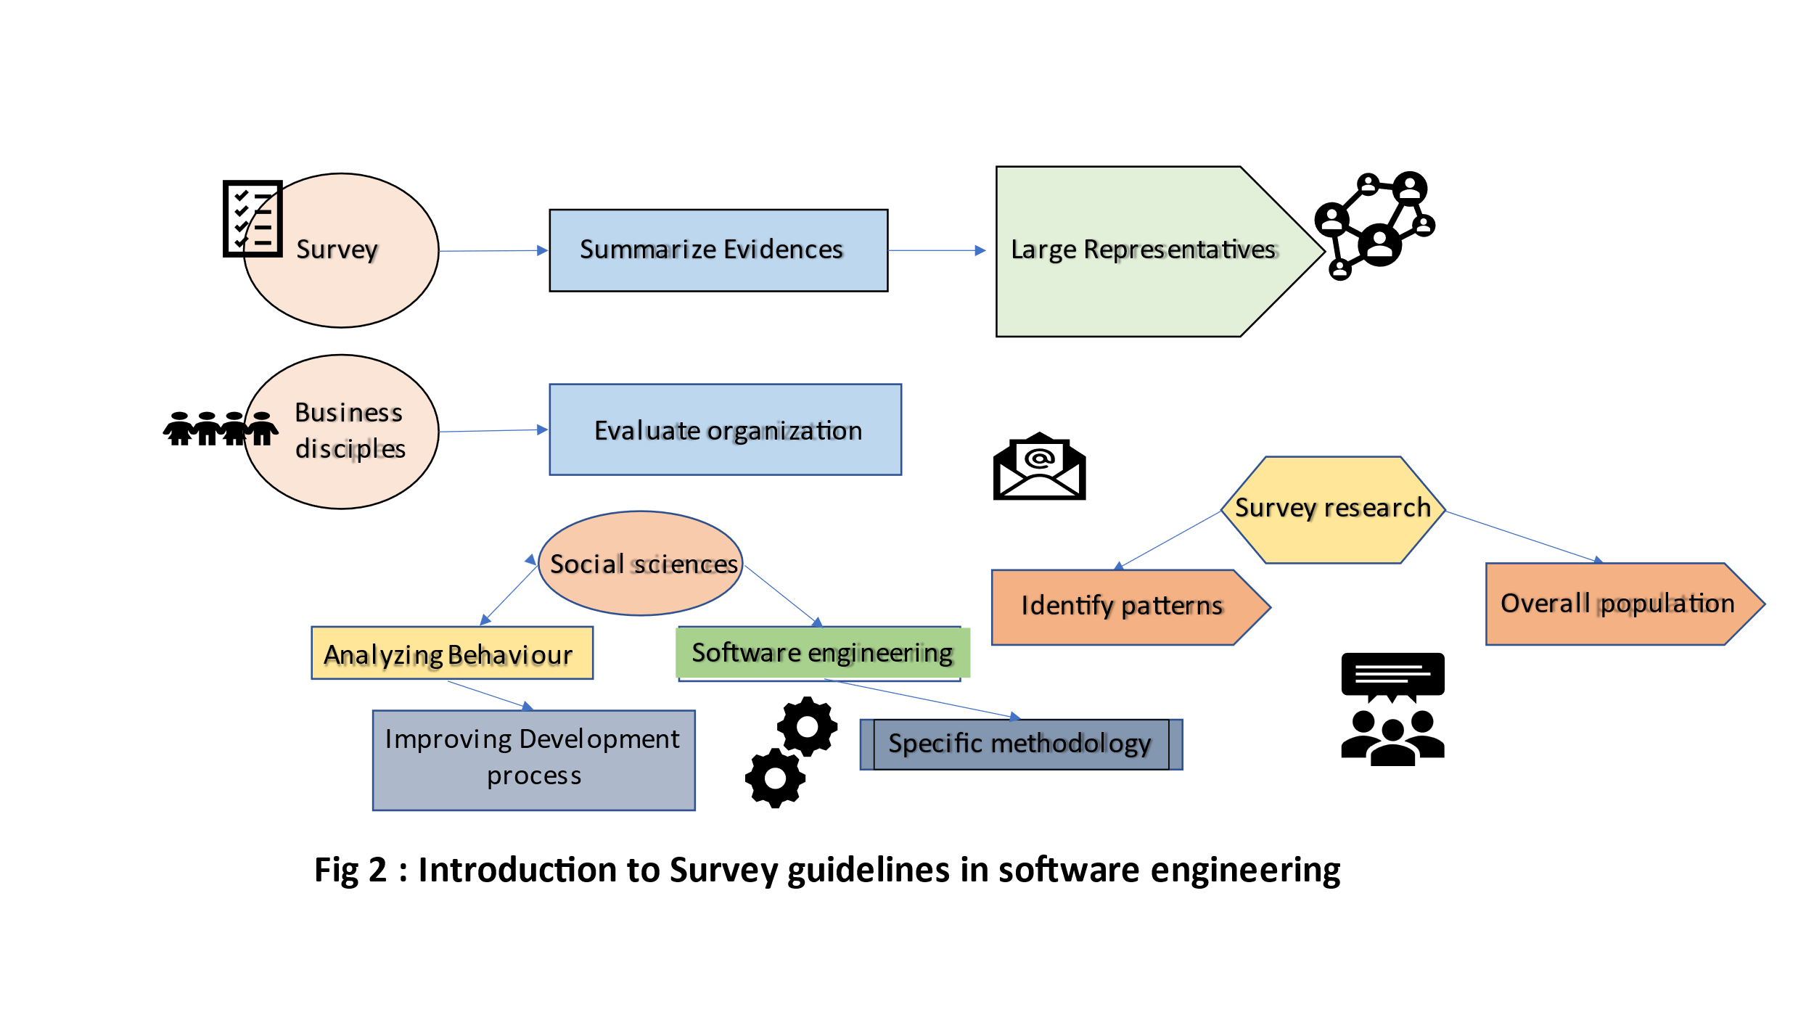

**Prior Art**

Reporting Experiments in Software Engineering has one major problem for integrating study results into a Common body of knowledge. That is the heterogeneity of reporting styles. Firstly, it was difficult to relocate relevant information and also important information was often missing the guideline on the expected content of the sections and subsections for reporting a specific type of empirical study, this topic presents the guidelines of unification for exporting experiments. [8] Guidelines for including every literature and conducting multivocal literature reviews in software engineering which induces both the academic and google scholar were termed as multivocal Reviews in educational research The main difference between an multivocal Literature reviews and Systematic Literature Reviews (SLR) is the fact that, while SLR’s use as input only academic Peer received proper Multivocal Literature Reviews(MLR’s) in addition also use sources from the Grey literature (GL) examples like blogs, videos, white papers and web pages. The purpose of the paper is to promote to provide specific guidelines for including (GL) and conducting Multivocal literature reviews recognise need for multiple voices rather than constructing evidence from only the righteous knowledge in academic settings A Software Engineering Research can improve its relevance by accepting and analysing input from participials review. [9] Scientific Research ontology to support systematic review software engineering is basically a term which is used to refer a specific methodology of research. It has developed in order to gather and evaluate the available evidence in a focused topic. Several primary studies have conducted in the studies field of software Engineering by determining an increasing improvement in methodology. Secondary study depends on primary Study results to be accomplished. In many cases software built with technologies and Processes for which developers have insufficient evidence to confirm their suitability, limits, quality, cost and inerrant rises of template. Designed to support systematic reviews in software engineering is presented, the development of ontologies to describe knowledge on experimental studies which is also introduced. Increasing its methodology quite growing rapidly. [10]The types of software Engineering practices and techniques used in industry is important understanding Turkey has a vibrant software industry and its important to Understand the Practices. Our objectives are to characterize and grasp a high-level view on type of practice to achieve the objective we should systematically designed on online survey. Two hundred and two practicing software engineering practices in turkey to provide latest techniques and challenges. [11]Taxonomies in Software Engineering-mapping study and a revised taxonomy development method-Software Engineering [SE] is an evolving discipline with a new sub area being continuously developed and added. Result also show most developed in and ad-hoc way. Many Software Engineering taxonomies have been proposed in the literature A better clear understanding of how taxonomies have been designed and applied in software engineering could be very useful for the development of new taxonomies and evolution. [12]

**Fig 3**

The study selection represents Snowballing Search. It Contracts The measurements which validate the measurement errors and Processing errors. Measurements give Response and then the edited Response. The Prior Art of Search and Selection Process overview is starting from the Manual Search and by selecting study and learn all that update the included Article and retrieve it to the Snowballing Research.

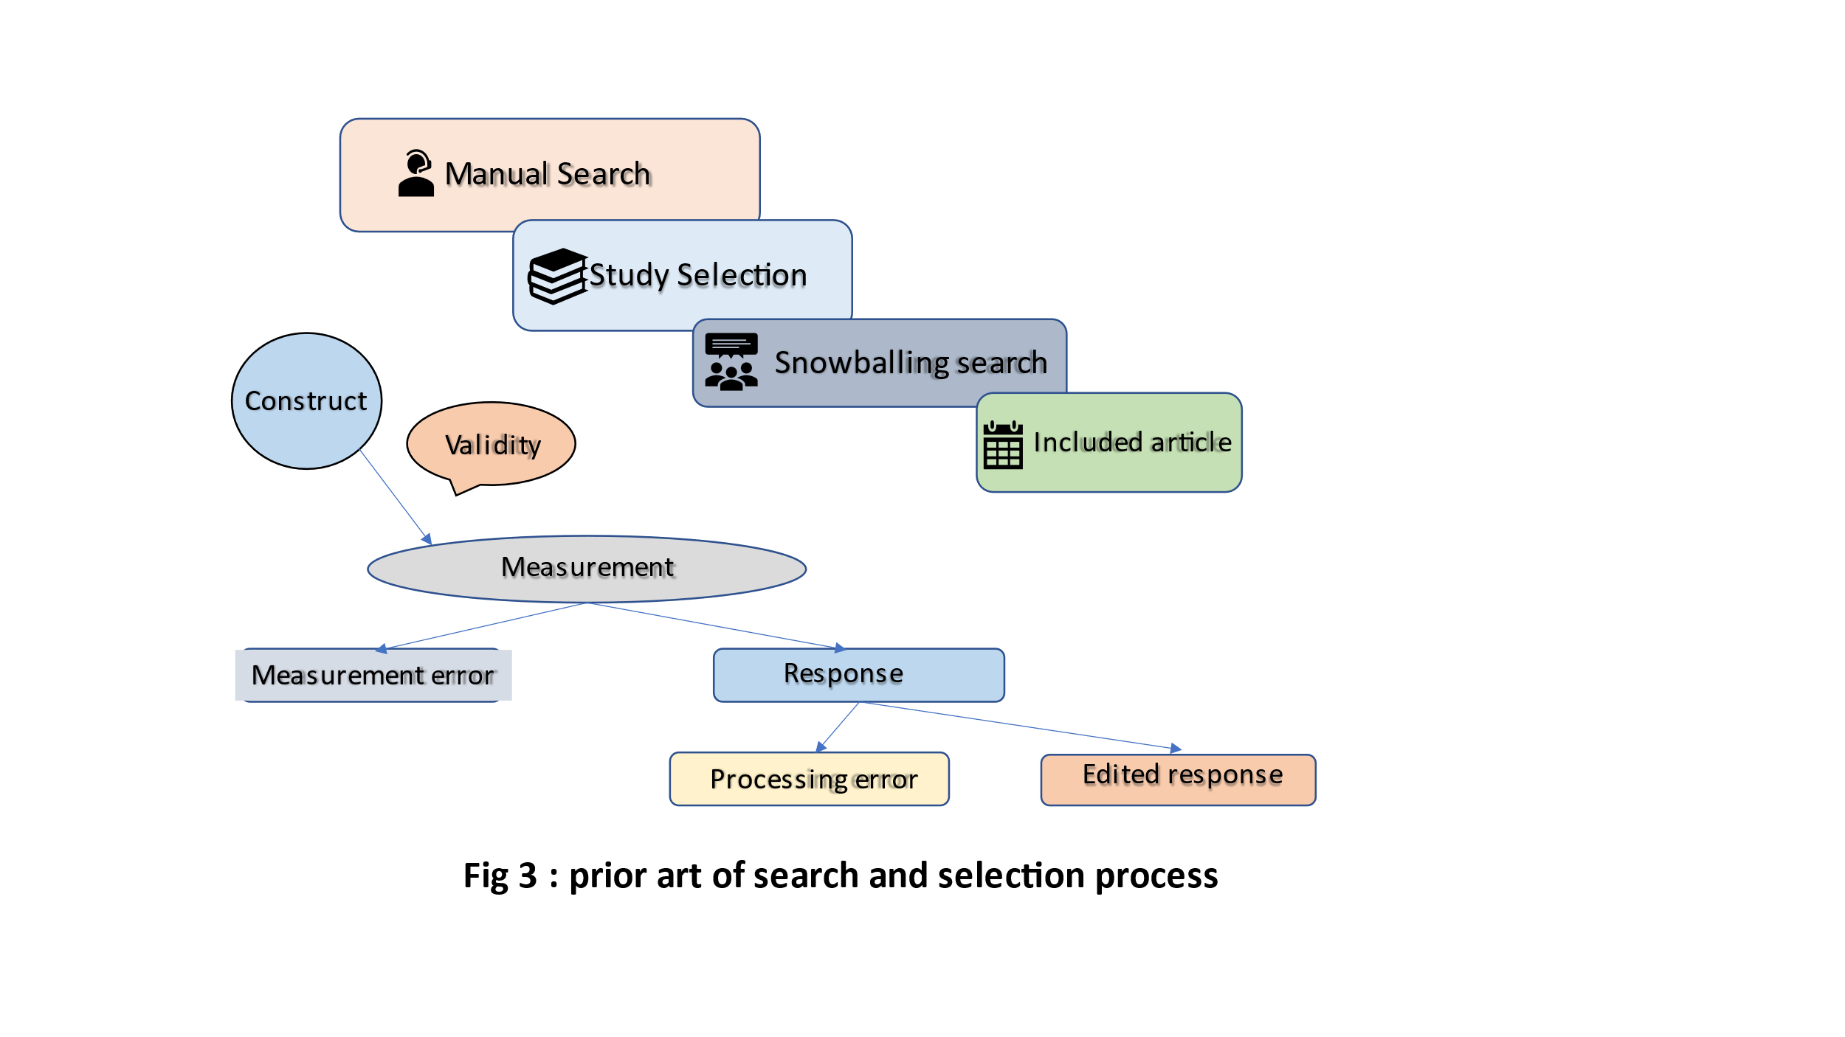

**Theory**

Research in Software Engineering analysis of the literature. most of the criticism and attacks have been supported by appropriate research The Software Engineering is arguably less than four decades old. Practitioners have been developing Software for longer than that of course example of criticism is to claim immaturity as accompanied by an analysis of the relevant literature to see papers or claiming advocacy. Research into software engineering trends to track the academic history of the field. The Software Engineering research where few outlets are interesting, Impressive. [13] Research Synthesis in software engineering tertiary Study. Developing Software Engineering knowledge is a cooperative enterprise of accumulation of evidence in an accurate fashion. The research cannot be interpreted with any confidence unless it is together. The evidence can be compared and contrasted to build knowledge and reads conclusion and empirical support. An accurate combination of study outcomes in research synthesis is therefore at the Scientific enterprise tertiary view and types of method review limited types and methods of synthesis. [14] Empirical Software Engineering has several factors particularly challenging as it requires Studying not technology. But Stakeholders activities such as activities. Researchers, in general, agree research design in empirical software Engineering research is challenging because the implications of using individual research methods are not recorded. The main objective of this article is to make researchers aware and support them in research design, providing foundation knowledge. Articles Provide a decision-Making Structure Containing several decision points representing a specific aspect of empirical Software Engineering research. The article provides a depth discussion of decision points concerning research design when conducting empirical research. Also, the intention is the structure should act as a string starting point for the research design before going into the details of the research search design. [15] Six years of Systematic literature receives in software engineering -tertiary study. Green high emphasis that evidence-based practice is not only about reading papers and summarizing and unbiased ways. It involves reading the right papers and changing behaviour. (SLR)’s can play an important role in Supporting research and education, and information Practice. In this article, we perform a mapping Study of (SLRs)’s in Software Engineering published. (SLR)’s plays an important Research, education, and information Practice on the impact and effect of technology. [16]Theoretical and Practical issues in evaluating the number of conceptual modes in the current State and future directions. An international standard has now been established for evaluating the number of software products. Where there is no equivalent standard for evaluating the quality of conceptual models. Where the result is the conceptual models continue to be evaluated in practice Considering how subjective opinions and experience common Sense. For conceptual modelling to progress from an art to an engineering discipline, quality standards to be defined, agreed and applied Finally we can describe with initial effort towards developing a common model quality. It provides future stand an indication effect. [17]

**Fig 4**

The Survey Process defines research objectives in choosing collection mode which is questionnaire construction and Which requires and measures the data coding and editing on post-survey adjustment and Hence Analyse-it. Also, the Research objectives choose a sampling frame that Designs and selects samples. There are two types of Data Collection and Data Analytics where Data Collection shows Survey Data and Frequency of Administration, and Data Analytics has two ways steps and tips, and methods.

**Current Status**

Integrating security Requirements Engineering into MBSE Profile and guidelines Models Based System design. Although there are many common points between MBSE and security requirements engineering MBSE security profile is formalized with profiling capacity. The paper represents the Security profile application use case and feasibility study of the current status of the security and systems engineering process. The new UML-based security profile confirms ISO/IEC cool information security standards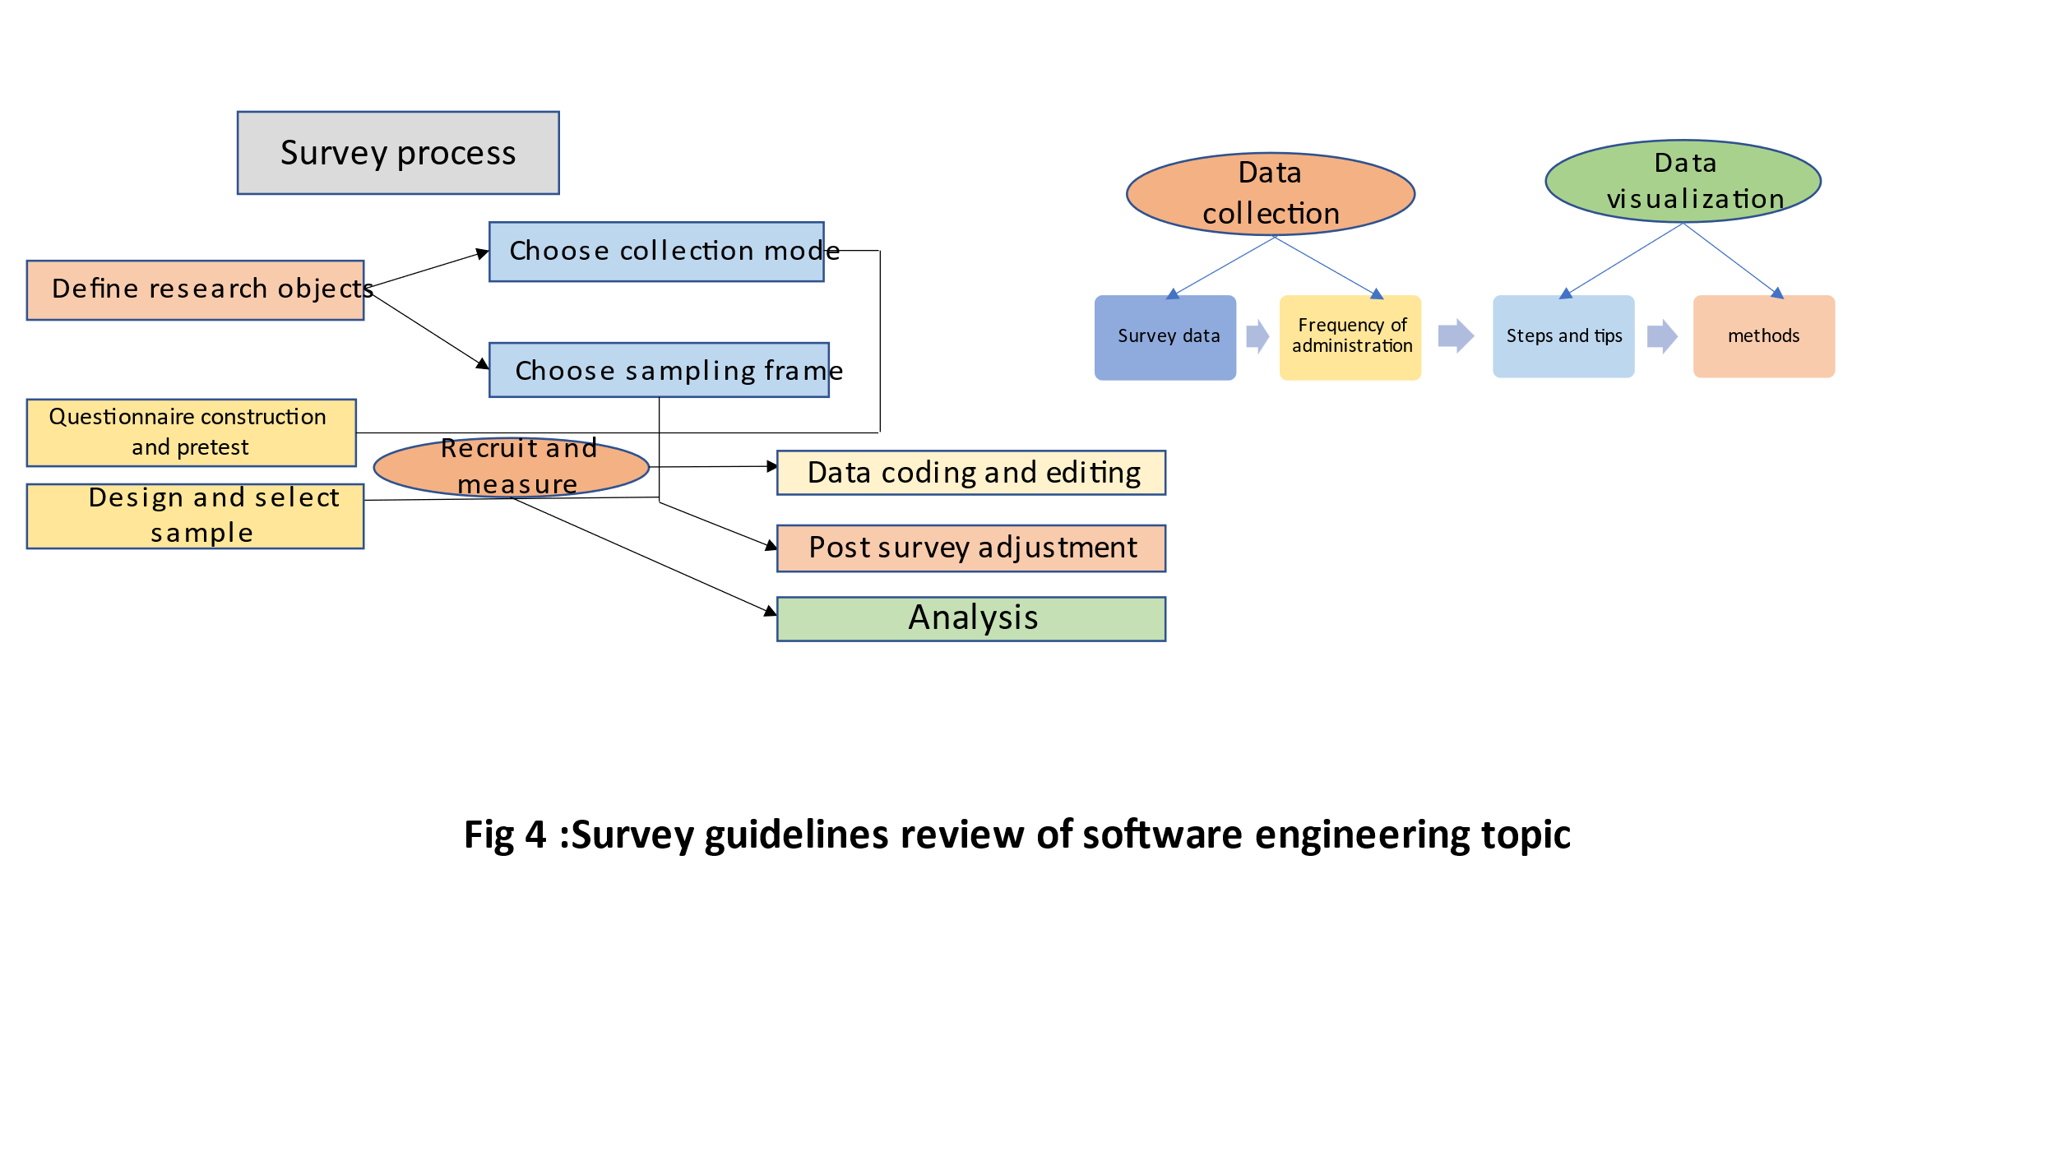. [18]A systematic literature review of block-chain based application: Current status, classification, and open issues. This work provides a systematic literature review of block-chain based applications across multiple domains. It investigates the current status of blockchain technology and its applications and highlights how specific characteristics of this disruptive technology. In the end, the theoretical underpinnings of numerous. research papers were published in high-ranked scientific journals. Based on a Structural systematic review and thematic content analysis of the discovered literature. Its comprehensive classification of block-chain enabled application across diverse sectors Such as business, healthcare, IoT, Privacy, and data management, establish key themes, trends, and emerging areas to research and point out the shortcomings in the relevant literature, and limitations in a block. Chains technology on Building the Findings, it identifies Various research gaps that anticipate academics and practitioners significantly. [19] Current status, opportunity, and challenges of augmented reality in education. Although augmented reality has gained much research attention in recent years, the team AR was given different meanings by varying researchers Arguing to view AR as a concept rather than a type of technology would be more productive for Educators, researchers, and designers The instrumental approach adopted by our AR system and alignment among technology design, instructional approaches Outline technological, Pedagogical, learning opportunities, issues related to the implementation of AR in education. This Article provides a possible solution to some of the challenges and also Support future research topics and issue. [20] A systematic literature review of literature review in Software testing new comes or industrial practitioners are likely to experience difficulties in digesting a large volume of knowledge in software in software testing. The goal of this study is to systematically Map in this study is to systematically map, in secondary studies it is software testing in an ideal world the Study is Systematic where all knowledge used in industry, education, and research is based on high-quality evidence. The authors believe that a tertiary study should be like the index of a book. A complaint often heard from practitioners is that academic literature is unpreventable due to the literature of shell volume. [21] Architecting for usability is to evaluate the quality because it expresses the relationship between the software and the domain of its application Software is developed with a particular purpose, to provide specific functionality to allow a stack holder to support a task in a specific context. Software that provides much functionality but is awkward to use will not sell, stakeholders such as users and the context in which they operate are an essential part of the domain of its application. The statement not only holds for public Software but also for as-turn-developed Software. [22]

**Fig 5**

The Current Status of the survey Research is based on project planning which requires a properly well-equipped definition which designs and develop more equipped definition which designs and develops more enthusiastic projects and tests them by installing and accepting them. Employee engagement shows the Benchmark Results, visualizes results, quantifies the data, set clear goals, and segments your data.

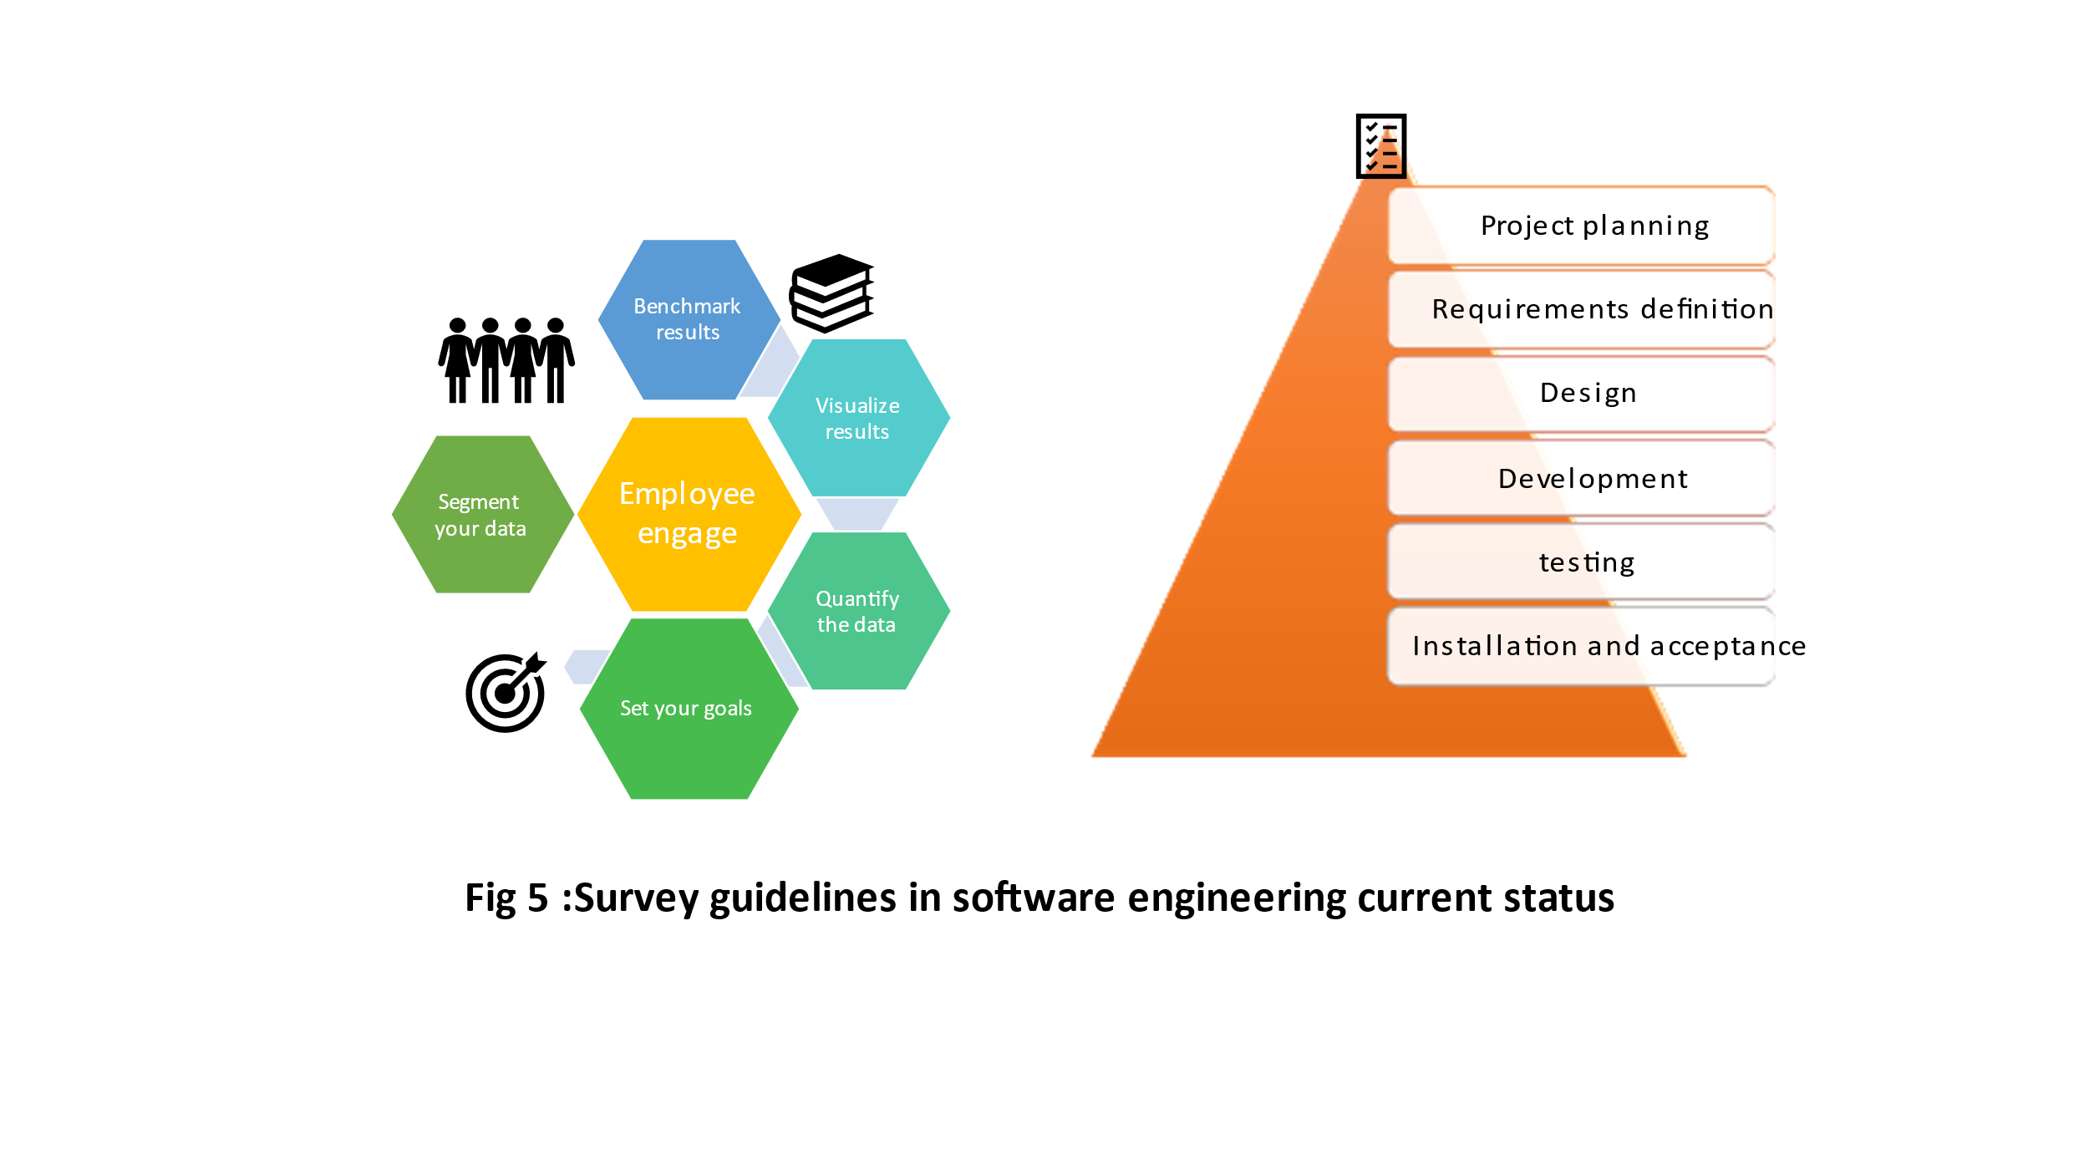

**Future Scope**

Starting with the aim of modernizing legacy systems, often written in old programming languages, reverse engineering has extended its applicability to virtually every bind of software System. The author's position is the next stage of development for these requirements is necessary to be based on empirical evaluating methods. The methods are originally designed dramatically it understands and modifies existing software. Evaluation is required to gain knowledge about the actual efforts of applying a given approach as well as to convince the end users of the positive cost-benefit trade of the state of the art to have future research fields. It has a clarifying scope of the investigation, defines a reference taxonomy, and adopts a framework for the experiments of execution. [23] On the generation of requirements speciation’s from software engineering models. A. Systematic literature review system and software requirement documents play a crucial role in software engineering where they both communicate requirements to clients in an understandable manual and define requirements in practice detail for system developers. Lists benefits are two one written in natural language and software engineering models. Requirement list both make validation of requirements by client’s caries and clarify the size of the project and the actual state of the requirements development the study proposal will combine textual requirements, business (system), or software models which becomes similar. [24] Replication of empirical studies in software engineering research: systematic mapping Study. In this article, the goal is to plot a landscape of currently published replication of empirical in software engineering research systematic reviews method to search and select published articles. The topics of Software requirements, Software constructions, and software quality concentrated over 55% of the replications, while software design, configuration, management, and software tools and methods were the topics with the smallest number of replications. We still need incentives to perform external replications, better standards to report empirically studied, and replication where collaborative research agendas that would speed up development and publication. we conclude in the last few years. Particularly considering the breadth of topics in software engineering. [25] Identifying, Categorizing, and Mitigating threats to validity in software engineering secondary studies are valuable to threats to validity lack of systematic approach to identify, categorize, and mitigate threats to validity Secondary studies. Result in recent years, secondary studies are more likely to report their threats to validity. Wherever presentation may be presented with a different name or different category. It is validated by an empirical study. [26]Kanban in software engineering: Systematic Mapping Study. Kanban is increasingly used to achieve Continuous development and delivery value in the software Industry. Kanban in software is growing these articles are largely descriptive and there is limited rigorous research on Kanban software and cohesive building of Cumulative knowledge. It investigates the Scientific evidenceMapping Kanban literature. [27]

**Fig 6**

The Future scope of Survey Based Research is to have more Scope of cost. Developers should reveal more Programming Developers should research more information from a sample of individuals through their responses. Researchers Proposal should be recommended as situations to this problem. Developers Should do the validation which should a set of techniques. Developed by Unifying.

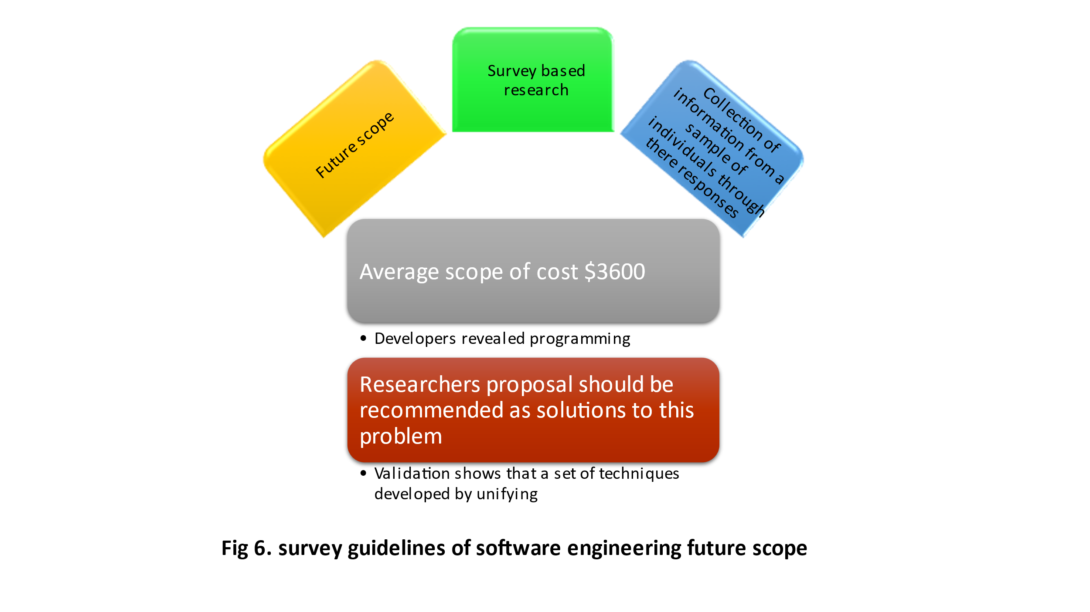

**Conclusions**

The Survey Generalizes the findings, and the Aims are to identify problems in ‘different researches of Software Engineering facing subway designs and the mitigation strategies. Guidelines for conducting systematic mapping studies in software engineering are done in the use to structure a research area. The services are focused on gathering and synthesizing evidence. Engineering taxonomies have been proposed in the literature A better clear understanding of how taxonomies have been designed and applied in software engineering could be very useful for the development of new taxonomies and evolution. research in Software Engineering analysis of the literature. . A complaint often heard from practitioners is that academic literature is unpreventable due to the literature of shell volume.

**Acknowledgements**

This research is funded by student Research grant from RV University through technical writing course.

**References**

# Works Cited

|  |  |  |
| --- | --- | --- |
| [1] | M. C. B. F. a. I. J. Punter, pp. 80-88, 2003. | |
| [2] | D. I. K. Sjoeberg, "A survey of controlled experiments in software engineering," *IEEE,* pp. 733-753, 2005. | |
| [3] | S. V. L. K. Kai Petersen, "Guidelines for conducting systematic mapping studies in software engineering: An update". | |
| [4] | S. Baltes. | |
| [5] | P. B. Barbara Kitchenham. | |
| [6] | B. A. K. D. B. M. T. M. K. Pearl Brereton. | |
| [7] | O. P. B. D. B. M. T. J. B. S. L. Barbara Kitchenham. | |
| [8] | A. C. M. P. D. Jedlitschka. | |
| [9] | M. F. M. V. M. Vahid Garousi. | |
| [10] | P. G. M. A. C. C. N. T. U. C. G. H. T. Jorge Calmon de Almeida Biolchini. | |
| [11] | A. C. A. B.-C. O. D. Vahid Garousi. | |
| [12] | R. B. J. B. E. M. Muhammad Usman. | |
| [13] | I. V. V. R. R.L. Glass. | |
| [14] | T. D. Daniela S. Cruzes. | |
| [15] | C. A. A. Wohlin. | |
| [16] | A. L. S. S. S. A. C. C. F. C. V. M. F. F. M. Fabio Q.B. da Silva. | |
| [17] | Daniel L. Moody. | |
| [18] | D. M. a. Butleris. | |
| [19] | T. K. D. C. P. Fran Casino. | |
| [20] | *. S. W.-Y. L. b. ,. H.-Y. C. c. ,. J.-C. L. d. Hsin-Kai Wu a. | |
| [21] | M. V. M. Vahid Garousi. | |
| [22] | J. B. Eelke Folmer. | |
| [23] | P. T. M. D. B. B. a. Tonella. | |
| [24] | A. T. Joaquín Nicolás. | |
| [25] | F. S. M. F. A. a. da Silva. | |
| [26] | S. B. P. A. M. V. A. C. Apostolos Ampatzoglou. | |
| [27] | D. D. K. C. M. O. Muhammad Ovais Ahmad. | |
|  | |
|  | |

|  |  |
| --- | --- |
|  |  |
|  |  |
|  |  |
|  |  |
|  |  |
|  |  |
|  |  |
|  |  |
|  |  |
|  |  |
|  |  |
|  |  |
|  |  |
|  |  |
|  |  |
|  |  |
|  |  |
|  |  |
|  |  |
|  |  |
|  |  |
|  |  |
|  |  |
|  |  |
|  |  |
|  |  |
|  |  |
|  |  |
|  |  |